Contents
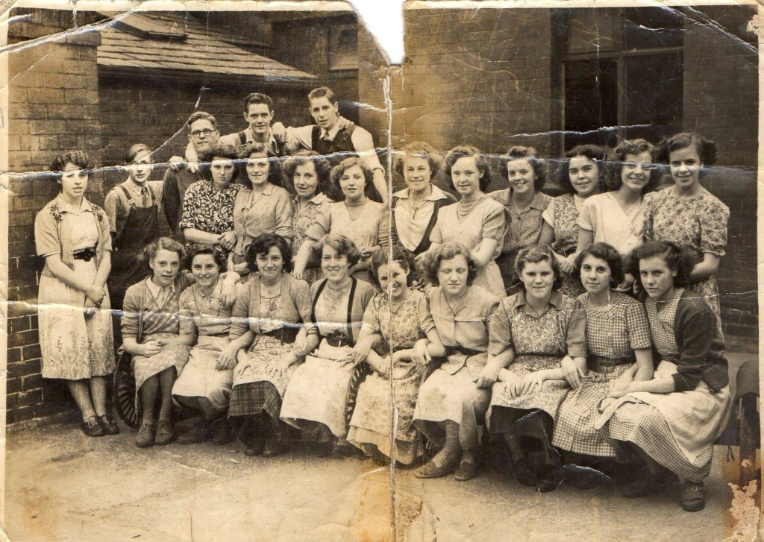  Chorley Mills  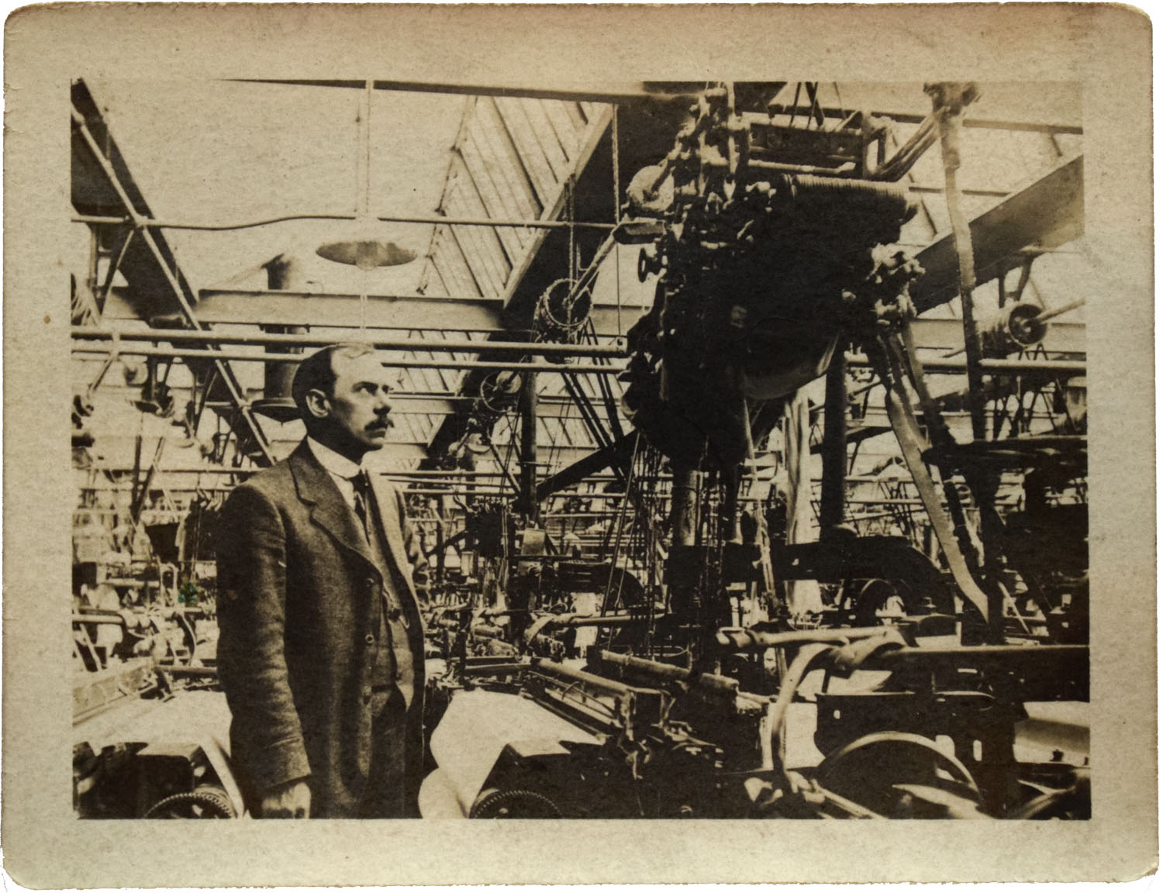 | Resource & Activity Pack  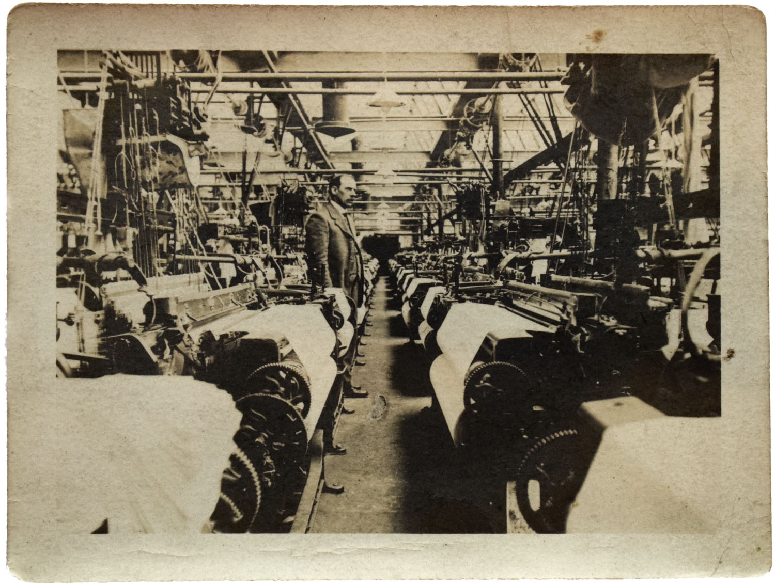

Introduction
Background to Cotton Production
Resource Mill Word Bank
Resource Jobs at the Mill Word Bank
Resource Personal Stories
Resource The Demise of the Cotton Industry
Resource Key Events in the North-West Textile Industry
Activity Talbot Mill 1939
Activity Historical Enquiry – Working in a Mill in the 1950s
Activity Then and Now
Activity Using Photographs as Historical Evidence.
Extension Activities
Introduction
This pack was funded through the support of HLF and volunteers.
Chorley Mills was a Heritage Lottery funded project to record and preserve memories for future generations of working lives in the last cotton mills of Chorley, Lancashire.
The history of our local town can shed light on the changes, movements and developments seen by society over time. This resource pack is designed to be used as a local history resource and is a starting point for lesson planning. The content can be adapted to suit Key Stages 1 - 4.
It brings together primary source material to support teachers in their delivery of the history curriculum (local history study in particular) and wider subjects including art and design, geography, citizenship and English. It will enliven and enrich learning about local history with local connections, familiar places and personal narratives that are not in text books.
Viewing mills and mill workers through a local lens will enable children and young people to gain a deeper understanding of how the work connected to all areas of local life and the challenges facing people in the past.
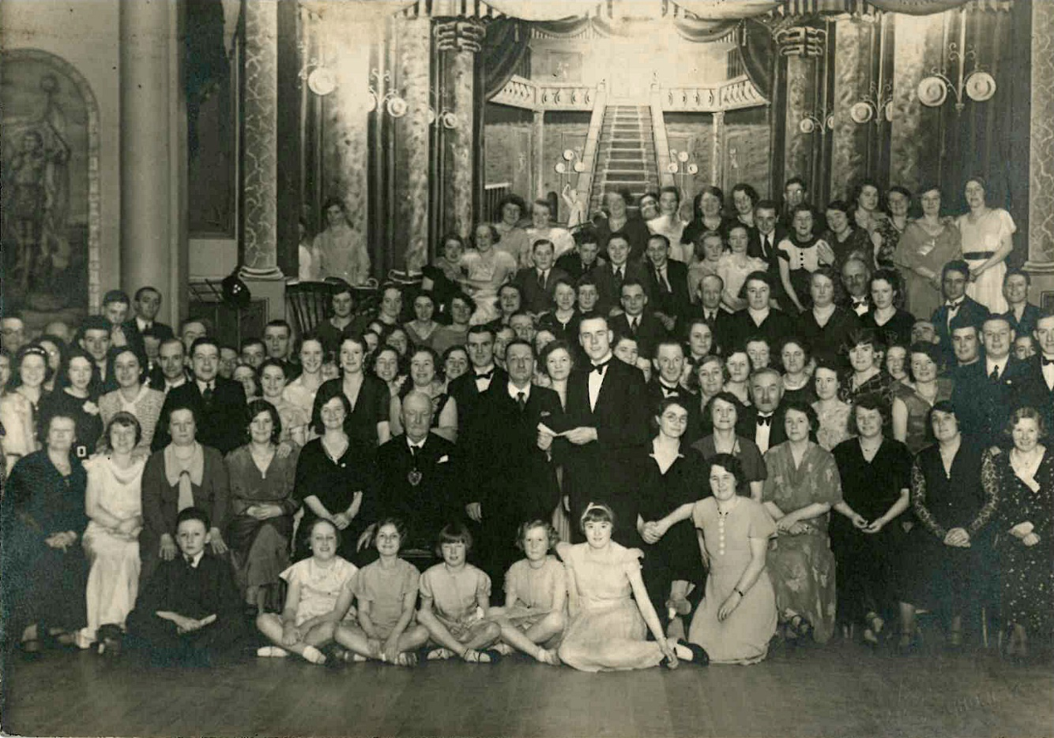
Fletcher’s Mill Ball 1935
Background to Cotton Production
Cotton was first imported to England in the 16th Century.
Raw Cotton was imported to Liverpool from the slave plantations in America (and later India and Egypt), and then transported to Lancashire to be made into yarn.
The development of transport between Liverpool and Manchester (trains and canal boats) led to a great increase in the cotton trade in Chorley and the surrounding towns.
The cotton trade in the nineteenth century was very important to major towns in Lancashire making it the centre of this industry.
Lancashire was one of the main centres of the cotton trade during the “Industrial Revolution”. The cotton trade produced lots of jobs and money and took over from the woollen industry.
By the mid-nineteenth century much of the production was done in the “cotton towns”, like Bolton, Bury, Chorley and Blackburn. Manchester was the centre where raw cotton was purchased and finished cotton and cloth sold.
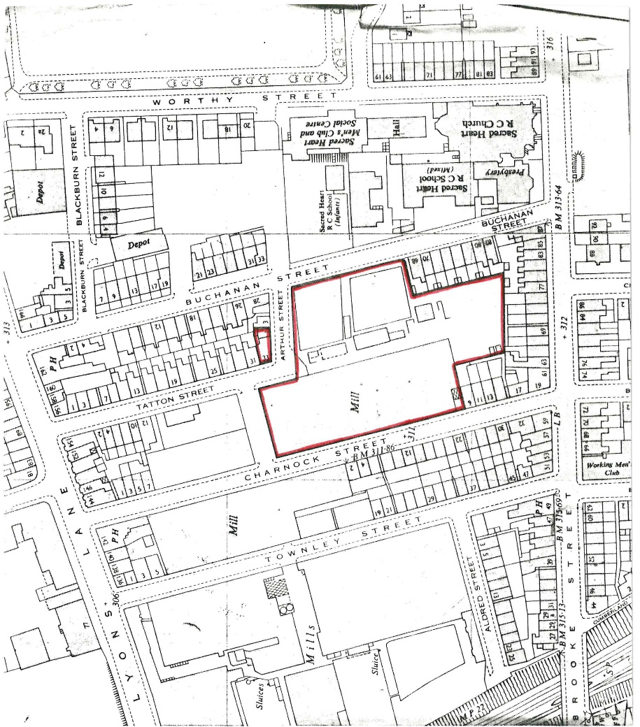 Fletcher’s Mill
Resource Mill Word Bank

Word | Description
Back | The underside of the cloth as woven in the LOOM.
Bale | A large package of raw cotton tightly bound and often wrapped.  Weighing: for American cotton, about 500 lbs.; for Egyptian, 700 lbs.; Brazilian, 250 lbs.; and East Indian, 400 lbs.
Band | The cotton belt that drives the SPINDLE of textile machinery.
Beam | A roller on a loom.  Warp beam - a roller at the back of the loom on which warp is wound.  Cloth beam - a roller at the front of the loom on which the woven cloth is wound.
Bobbin | A spool on which thread is wound.
Boll | The seedpod of the cotton plant.
Bolt of Cloth | A rolled or folded length of cloth.
Calico | White cotton cloth often printed with a pattern.
Carding | Disentangling and straightening the fibres of raw cotton or wool

Cop | A tube carrying yarn.
Devil | A machine for loosening the raw fibres.
Doff | To remove a filled package or beam from a textile machine. Frequently the operation includes replacing the full package or beam with an empty one.
Finishing | A series of processes by which cloth is made ready for use e.g. bleaching, dyeing, printing.
Fustian | A coarse cloth of cotton/linen or cotton/wool mixture.
Gin | A machine for removing the seeds from the cotton fibre.
Grey Cloth | Unbleached cloth.
Hank | A measure of yarn varying for different materials; the cotton hank is 840 yards.
Heald | A part of the loom that separates the warp threads to form the gap or shed through which the shuttle passes.
Humidifier | A device that vaporises water and sprays it into the atmosphere in order to increase the amount of moisture in the air.
Jenny | A spinning machine invented by James Hargreaves.

Lap | A thick sheet of fibres.
Loom | A weaving machine.
Mule | A spinning machine invented by Samuel Crompton, combining elements of the jenny and the water frame.
Neps | Short immature fibres, or portions of mature fibres which are tangled and broken.
Picker | A block of leather or wood which knocks the shuttle across the loom.
Piece Work | Payment by the amount of cloth produced rather than the hour.
Pirn | A type of cop holding the yarn.
Respirator | A device for covering the mouth and nose, worn by the card stripper to prevent the inhalation of dust and lint.
Ring Frame | A spinning machine in which the spindle turns within a ring.
Roving | A thin, drawn out sliver ready for spinning.
Scutcher | A machine which breaks up and opens the raw cotton in preparation for carding.

Shed | 1 - The gap in the warp through which the shuttle carries the weft thread.  2 - A weaving factory.
Shuttle | The device that carries the weft thread across the loom.
Sizing | 1. A stiffening substance used to give yarn strength, stiffness, and smoothness, which improve its weaving qualities.  2. Treating yarn with a stiffening substance to improve its weaving qualities.
Skein | A continuous strand of yarn arranged in a loose coil.
Sliver | A soft rope of loosened cotton taken from the carding machine.
Slub | A thick place in a strand of yarn caused by improper spinning.
Spindle | A thin tube on to which the spun yarn is wound.
Spinning | Drawing out and twisting fibres to make threads.
Tackler | The supervisor responsible for the working of a number of power looms and the weavers who operated them.
Throstle | A spinning machine developed from the water frame.
Warp | The lengthway threads in a loom.
Waterframe | A spinning machine invented by Richard Arkwright.
Weaving | The crossing of warp and weft threads to make cloth.
Weaver's Knot | A peculiar twisting knot used throughout the textile industry. It can be tied very quickly, does not slip, and is not easily detected.
Weft | The crossway threads in a loom, carried by the shuttle.
Winding | Creating bobbins or spools of yarn.
Yarn | A spun thread.

Resource Jobs in the Mill Word Bank
Baler | Someone who carried the bailed wool or cotton goods in a mill.
Bobbin Carrier | Worked in spinning and weaving sections of the mills.
Bobbin Turner | Made the bobbins used in the spinning and weaving industry.
Bowker | Bleached yarn and a local term in some parts of Lancashire for a butcher.
Calico Printer | Dyed and coloured calico.
Cardroomer | Anyone who worked in the carding room of the mills.
Cardmaker | The maker of cards or instruments for combing wool.
Cloth Lapper | Took the cloth from the carding machine readied it for the next process.
Cloth Linter / Picker | Removed unwanted threads & lint from the finished material.
Dexter | Dyer.
Doubler | Operated a machine used to twist together strands of fibre (cotton, wool etc).
Drawboy | Weavers assistant in the shawl making mills,
Dyer | Employed in the textile mills to colour fabric prior to weaving.
Fettler | Cleaned the machinery in woollen mills, sharpened the fustian cutters knives or a needle maker who filed the needle to a point.
Filler | Filled the bobbins.
Fine Drawer | Employed in tailoring to repair tears in the cloth (invisible mending).
Firebeater | Tended the boilers that powered the machinery.
First Hand | Silk weaver who had his own loom (an outworker).
Frame Spinner | Worker on a loom.
Frameworker Knitter | Operator of a machine which made hosiery.
Heck Maker | Maker of a part of a spinning machine by which the yarn is guided to the reels.
Hotpresser | Worker in paper or textile industries where the product was pressed between glazed boards and hot metal plates to obtain a smooth and shiny surface.

Lace-drawer | Child employed in lace work, drawing out threads.
Lace-runner | Young worker who embroidered patterns on lace.
Lotter | Person who bought odd lots of wool and consolidated them for sale.
Mule Minder | Minded the spinning mules.
Orrice Weaver | Designer of lace patterns to be woven with silk thread and silk.
Outworker | Worker who carried on their occupation at home.
Overlooker | Superintendent or overseer.
Pack Thread  Spinner | Operator of the machine which made thread or twine.
Picker | Person who cast the shuttle on a loom.
Piecener / Piecer | Pieced together any threads which broke.
Power Loom  Turner | Maintained the looms.
Quiller | Operated a machine that wound yarn onto spools.
Reeler | Operated the machine that wound the yarn onto the bobbin.

Say Weaver | Person who made Say - the material used for table cloths or bedding.
Scribbler | Employed in a scibbling mill where the wool was roughly carded before spinning.
Shuttle Maker | Made the shuttles for the weaving mills.
Silk Thrower | Worker in the silk industry.
Silker | Sewed the ends of the fabric to prevent the layers from separating.
Silk Dresser | Prepared the silk for weaving.
Silk Twister | Silk spinner.
Slubber Doffe | Removed the bobbins from the spindles.
Stockinger | Knitter, weaver, or dealer in stockings.
Stripper | Employed in the woollen trade to remove the rubbish from the carding machines.
Teaser | Opens up matted wool for carding.
Throwster | Twisted the strands of fibre together into yarn.

Twister /  Twisterer | Operated the machine used for twisting yarns and threads together
Twist Hand | Operated a lace machine.
Walker /  Waulkmiller | Cloth worker.
Whitener /  Whitester /  Whitster | Person who bleached cloth.
Windster | Silk winder.
Wool Driver | Person who brought the wool to market.
Woolen Billy  Piecer | Worked in the woollen mills to piece together the broken yarns.

Personal Stories Irene Patten and Katherine Jackson
Irene and Katherine both worked at Talbot Mill in the late 1950’s in the spinning area. They were both recorded as part of the Chorley Mills project. They mention wartime Austrian refugees who worked at the mill and had accommodation nearby.
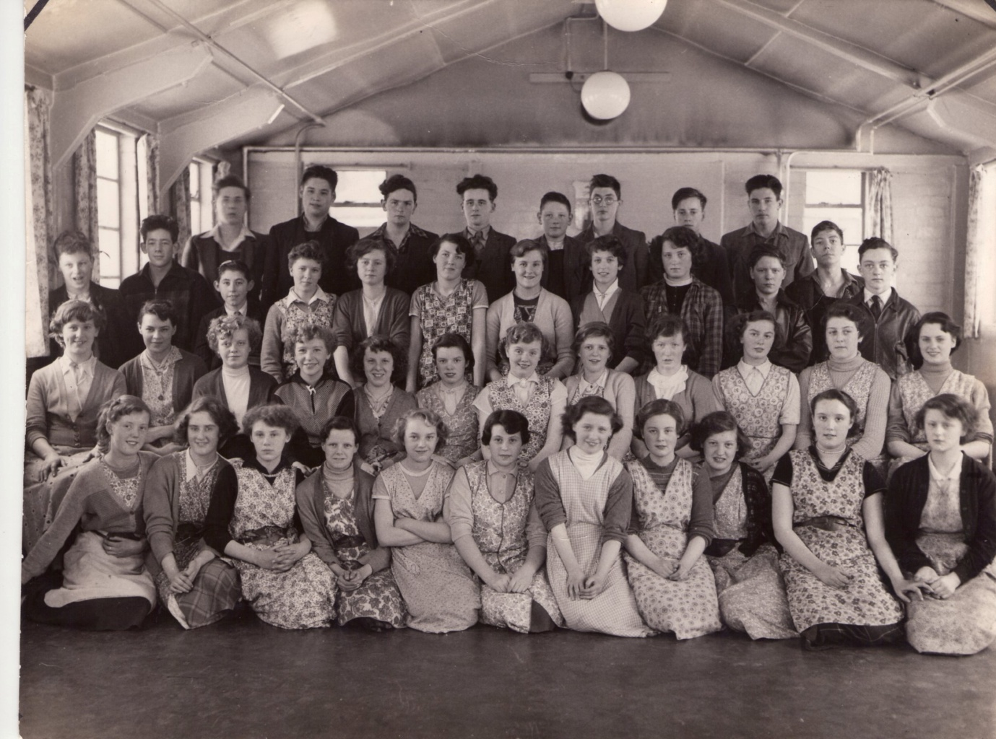

Both these ladies were born at the start of the second world war and were school friends at Sacred Heart school.
Irene was born in 1939 and her mum was a weaver. She lived in Yarrow Road in Chorley. She had one sister and two children who died; one of spinabiffida and one of pneumonia. She went to Sacred Heart school and left at 15.
Kathleen was born in 1939 and her father was a builder and a jack of all trades. She had a sister and again children who died young. She went to St Mary's School and Sacred Heart. They went to look around the mill from school and were offered jobs.

Talbot Mill went through the whole process of making material and both worked in the winding room. They learned how to do hand knotting.
Work day
They started work at 7.30 until 5.30 with one hour for lunch. Cotton was transferred with cops (spindles full of cotton) which were put on cones. Knotters were a provided with a leather strap. When thread broke, it was their job to mend them.
Training
Training was given firstly in the knotting and then working on a frame. They had a supervisor who came and checked work. They were really interested at how the raw cotton came in and then went out as material. Every process was key to the next.
Wages
They were asked to work Saturday morning for 10 shillings to clean the machines. Wages were 2 pounds 5 shillings and 8 pence in 1954 and it was piece work. It was £3 when fully trained. Once she left she was earning £9 per week piece work so the quicker you were the more you earned. One elderly lady would come in a hour early so she could stack everything to speed work up.
People
Everyone got on - they were all local people. All different age groups. Some ladies were from Austria who lived in chalets in the mill grounds. They didn't see a lot of men. They came over from Austria to get away from the war. Fled because Germans were invading Austria.
Food
The canteen - 'I met my husband here on maintenance. He had to come through the winding room to get to the canteen. When I first started you had a canteen voucher. You could take your own lunch and make cups of tea. There was a hot water boiler in the winding room. A 10 minute break in the morning and we used to sing when doing work. I usually had cheese butties. I had been known to run home at lunchtime to see if my boyfriend, a sailor, had written to me.'

Health and safety
On the move all the time. It was the fluff that was constantly in the air. They swept all the fluff up on a Saturday morning.
They walked along the canal bank to get to work from Stevenson Street.
Neither remember being off ill.
Clothes
Cotton wrap around overalls, shoes - nothing special, just comfortable. They had to buy their own pinny from Sharples. You could wear a turban on your head to keep the fine fluff off. A scarf that was made into a turban. Make a triangle from a square. Wide part at the back and tie at front.
Holidays
Wakes weeks, Chorley hols, second week of July. Worked new years eve and bank holidays. Got New Years day off and go to the pub at the top of Bagganley.
They left to get married to a sailor and to work at the ROF when they were 18.
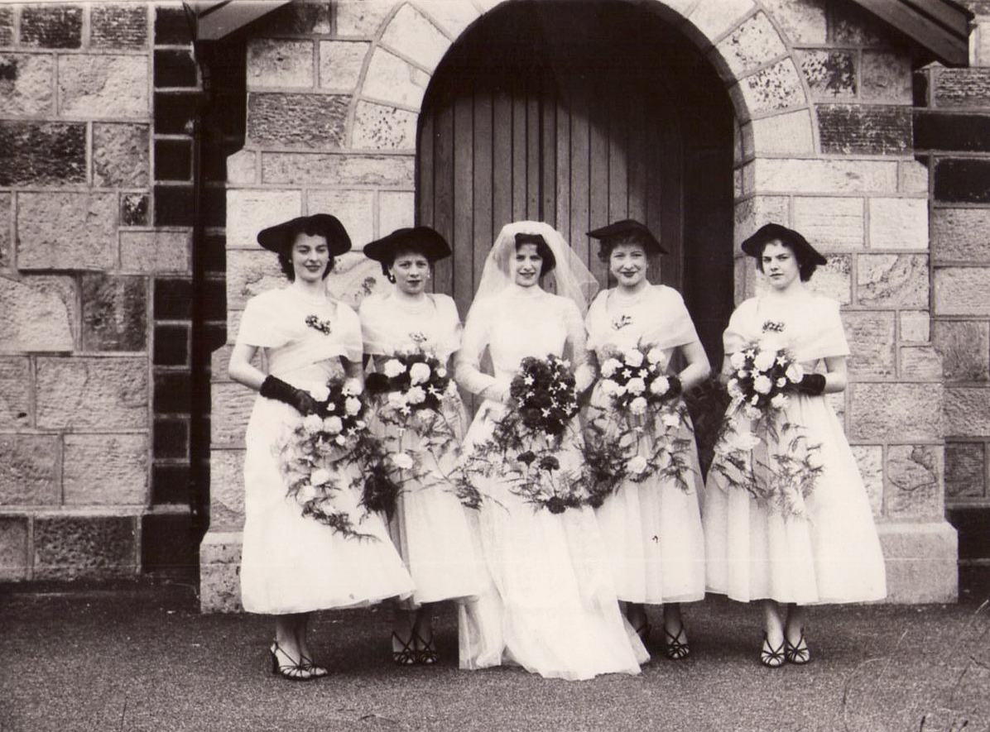
The Demise of the Cotton Industry
The cotton industry remained prominent into the twentieth century, but in the 1930s it declined rapidly. It suffered from competition from the Far East.
The Greater Manchester area became specialised in producing man-made fibres, because of a strong base in the chemical industry
(you could try asking the children to name man-made fibres here, and identify those that they are wearing)
The textile industry still functions in Greater Manchester, but its prominence is much reduced. This can be seen by the other uses to which cotton mills have been put. Botany Bay is an example of a mill now used as a retail and recreation site.
The War Years
By 1912 the cotton industry in Britain was at its peak producing eight billion yards of cloth, but the outbreak of World War One spelt disaster for textiles in the North West
During the war, cotton could no longer be exported to the foreign markets and those countries, particularly Japan, set up their own factories.
Not only were these countries producing their own cloth, they were doing it more cheaply than Britain.
By 1933 Japan had introduced 24 hour cotton production and became the world's largest cotton manufacturer.
The demand for British cotton slumped and mill owners put cotton workers on short time, or closed the mills altogether.
In-between the wars, 345,000 workers left the industry and 800 mills closed.
'Trouble at mill'
India accounted for half of Britain's cotton exports, but as part of his campaign for Indian independence, Gandhi called for a boycott of imported Lancashire cotton.
The boycott had devastating effects on Lancashire and in Blackburn, with 74 mills closing in less than four years.
The First World War may have spelt the beginning of the end for the textile industry, but the Second World War brought about a short reprieve.
Lancashire mills were enlisted to make parachutes and uniforms for the front and mill owners were forced to rally up new recruits.
In the 1950s and 60s there was a huge influx of workers from the Indian sub-continent who were encouraged to seek work in Lancashire.
An increased work force allowed the mill owners to introduce a third shift or night shift to the working routine although many workers were less than pleased with the changing hours.

Too little, too late
The end of king cotton
The resurgence in the textile industry was short lived and by 1958, the country which had given birth to the textile industry became a net importer of cotton cloth.
The Cotton Industry Act of 1959 was intended to help modernise and amalgamate the industry.
Mill closures occurred throughout Lancashire, but cost cutting did little to improve industry profits. Lancashire was still failing to compete with foreign competition.
During the 1960s and 70s, mills were closed across Lancashire at a rate of almost one a week.
By the 1980s the textile industry of the North West had all but vanished. Only the empty factories and northern towns which sprung up as a result, were left - a legacy of an industry that was once the pride of Britain

Resource Key events in the North West Textile Industry
Date | Key Event
Pre 1760 | Cotton is spun by hand at home.
1760 onwards | The rise of the factory system.
1803 | Cotton overtakes wool as Britain's biggest export.
1820 onwards | The era of the machine - steam power allows machine-led production in the industry
1825 | George Stephenson builds the first public steam railway - the Stockton to Darlington line
1833 | The first Factory Act is passed regulating child labour
1847 | Government pass the Ten-Hour Act. The 70-hour week becomes 55.5 hours
1906 | Talbot Mill in Chorley opened 1910?
1912 | The industry reaches its peak, producing 8 billion yards of cloth
1914 | World War One - cotton can no longer be exported to the foreign markets. Those countries set up their own factories.
1933 | Japan introduces 24 hour cotton production and becomes the world's largest cotton manufacturer.
1950s | Huge influx of workers from the Indian subcontinent allowing extra shifts.
1958 | Britain becomes a net importer of cotton cloth.
1959 | The Cotton Industry Act is passed to help modernise and amalgamate the industry.
1960s/70s | Mills are closed across Lancashire at a rate of almost one a week.
1980s | the textile industry of the North West is over.

Activity Talbot Mill 1939
Timeline
Look at the aerial maps of Talbot mill.
- Find a modern map of the area (e.g. using Google Maps) – this will help you when using the historical resources.
- Familiarise yourself with the maps and photographs.
- Find a ‘marker’ that stays the same in each one (eg Talbot Mill, Eaves Lane or The Town Hall). This will allow you to place other things which have stayed the same, and see where the differences are.
- Find other landmarks such as rivers, canals, and churches to locate you on the map. Use the modern map to help you.

Now Look at the Timeline
Put any photographs and maps you have found in date order, starting with the earliest.
Once you have become familiar with the places shown on the maps start thinking about what has changed and what has stayed the same.
Note similarities and differences.
- Is there anything that stays the same on all the maps?
- Which parts of the map have changed the most?
- Why things have changed or stayed the same?

Activity Talbot Mill 1939
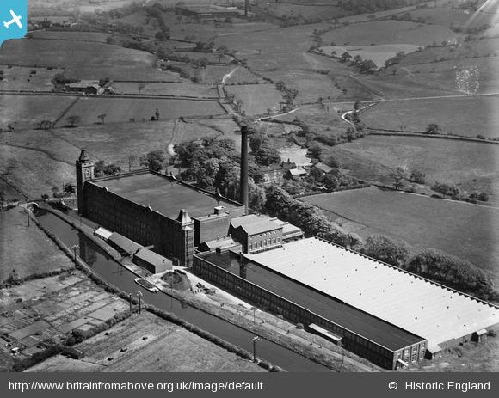
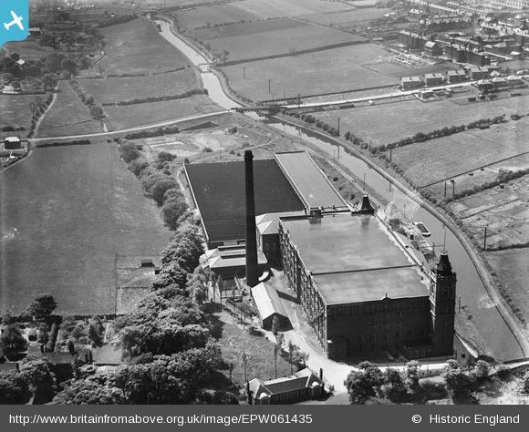
Activity Historical Enquiry - Working in a Mill in the 1950s
Statement | This is likely to be true – say why | This is likely to be false – say why | We would need to know more information – say what
The Mills were clean and tidy.

We worked long hours.

Everyone in the mills got on together.

We worked New Year’s Eve and Bank Holidays.

Raw cotton came in and went out as material.

Fluff was constantly in the air.

Activity Then and Now
Look at the photographs below of Mavis who worked at Talbot Mill in the 1950s and 1960s and the Ford factory worker.
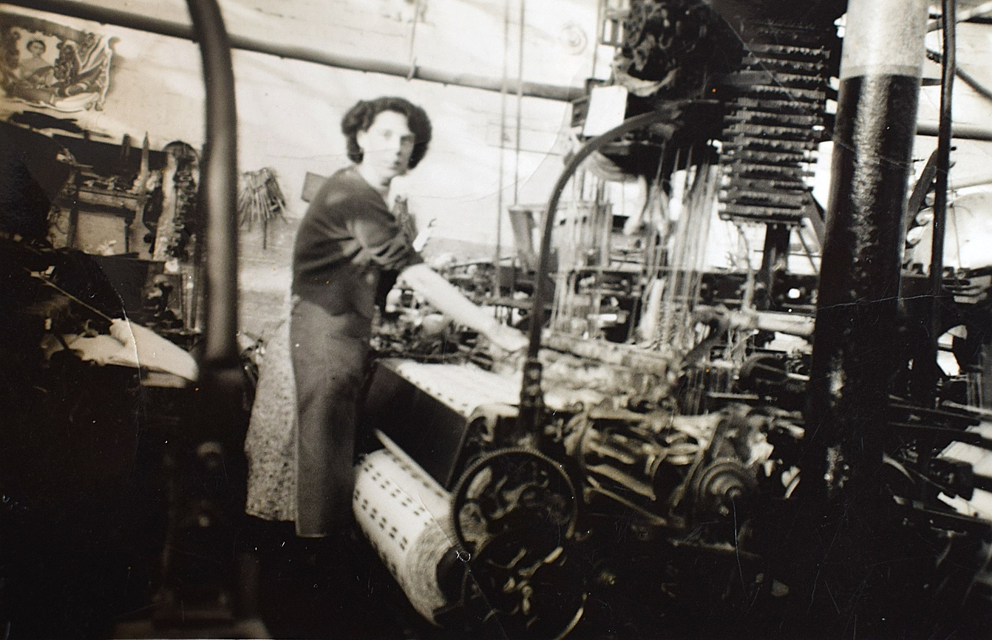
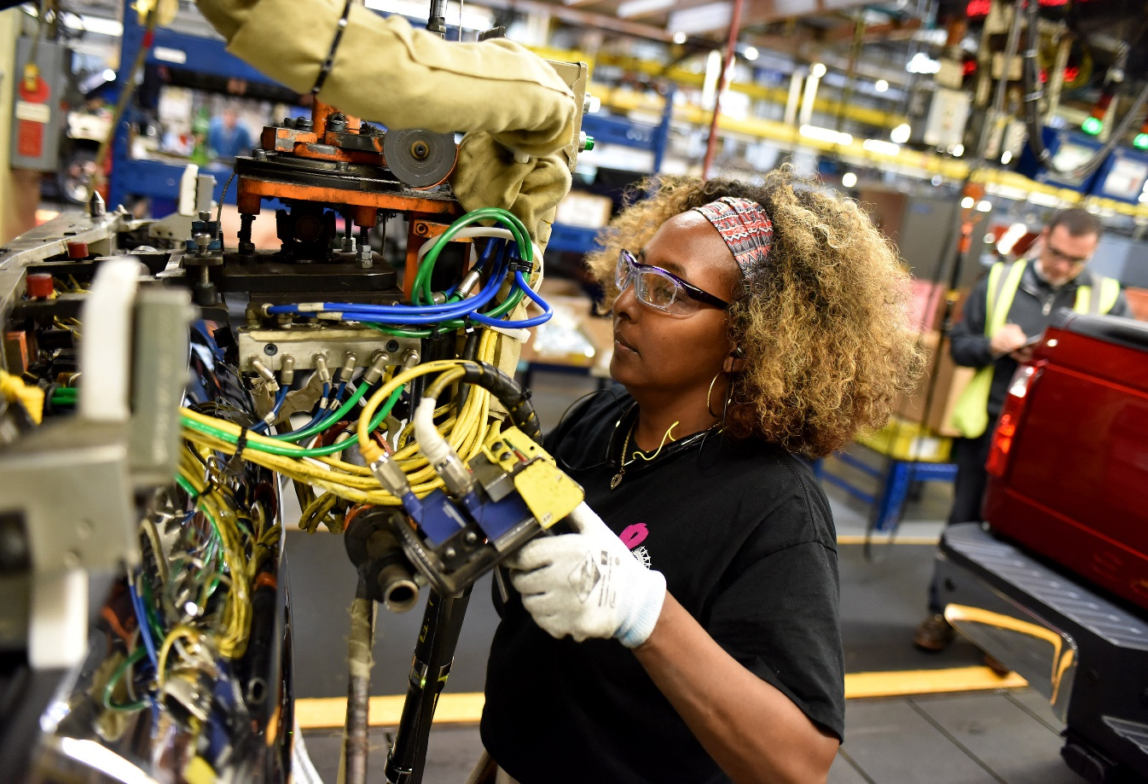

Activity Then and Now

Compare the pictures.
- What has changed and what has stayed the same?
- In your answer, write about clothing, safety equipment, presumed working hours, type of job.
- What can we learn from these photographs about life in the 1950s and 1960s?
- Why do you think these things have changed since the 1950s and 1960s?

Show these pictures to people you know who would have lived in Chorley in the 1960s.
What memories do they have of the mills?

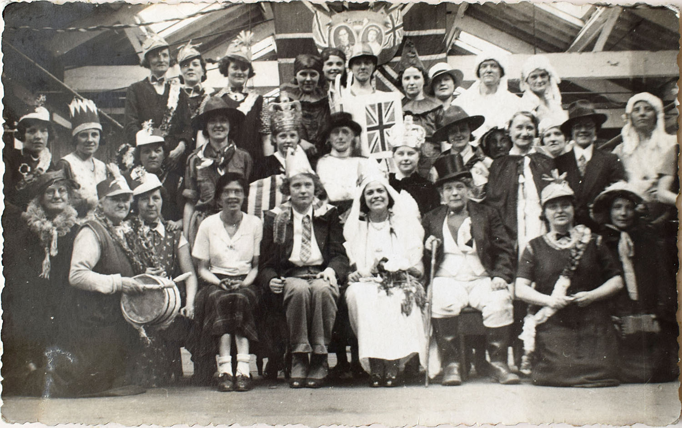
Croft Mill on the coronation of Queen Elizabeth II in 1953.
Photos courtesy of Mavis Cowling.
Activity Using Photographs as Historical Evidence
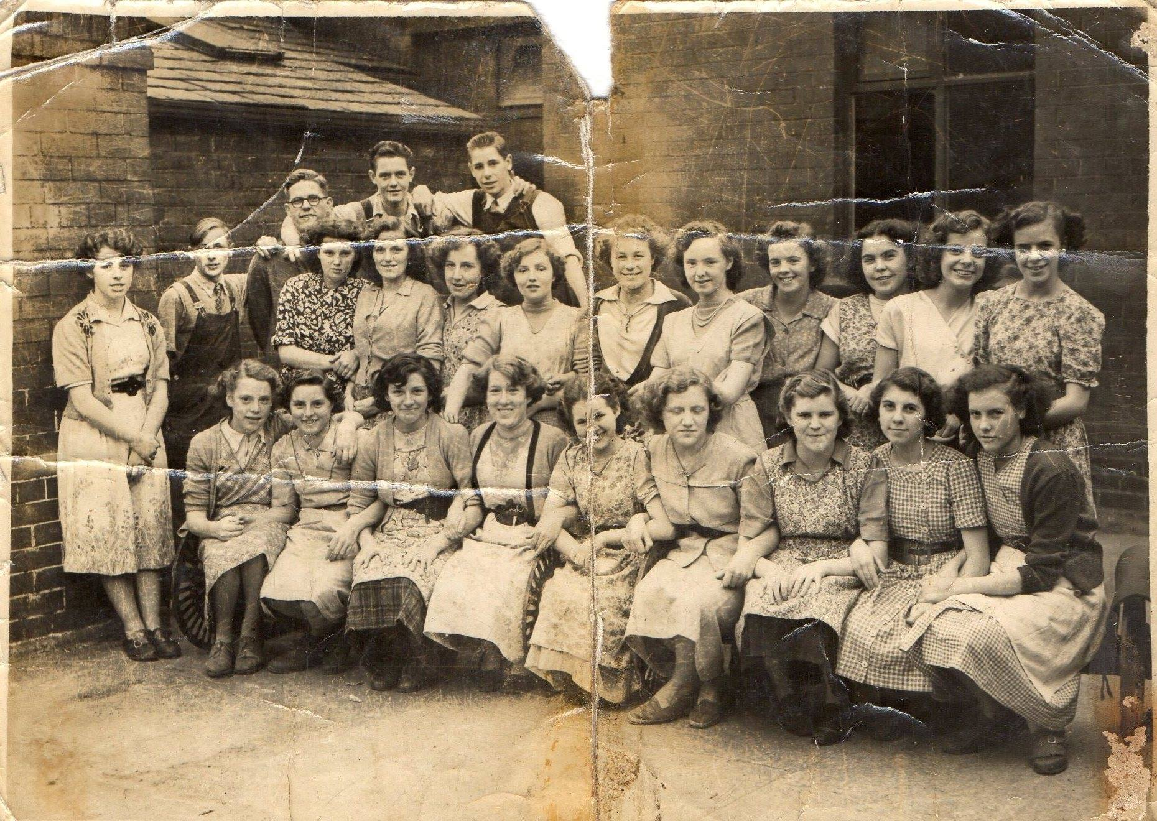

Activity Using Photographs as Historical Evidence

‘60 years ago work at Talbot Mill in Chorley was an easy job.’

Questions for discussion
- What evidence is there from the photographs to support this opinion?
- What reasons might you have to doubt this opinion?
- Find other pictures/newspaper reports to provide evidence for and against this opinion.
- Explain how one picture you have found supports the opinion and how one picture contradicts it
- Choose a favourite picture or other piece of evidence and explain why you like it.

Some words and phrases you might use
This piece of evidence is useful for answering the question because …
It is typical/untypical because …
It supports the view that …
It sums up life at the time because ...

Extension Activities Chorley Mills 60 years ago

Use pupil generated questions for a further enquiry.
Choose two or three pictures from the pack that would best sum up working life 50 or 60 years ago for a display.
Questions for discussion and starting points for projects
What can we learn about this aspect of life at the time?
What is the evidence from the photographs to support this view?
When did the roads become busy with cars?
What were ‘Whit Walks’?
Which picture was the most useful for finding out about this aspect of life?
Was everyone poor in Chorley 60 years ago?
Could people enjoy life in Chorley 60 years ago?
What further question would you want to ask about life 60 years ago, based on one or more of these pictures?
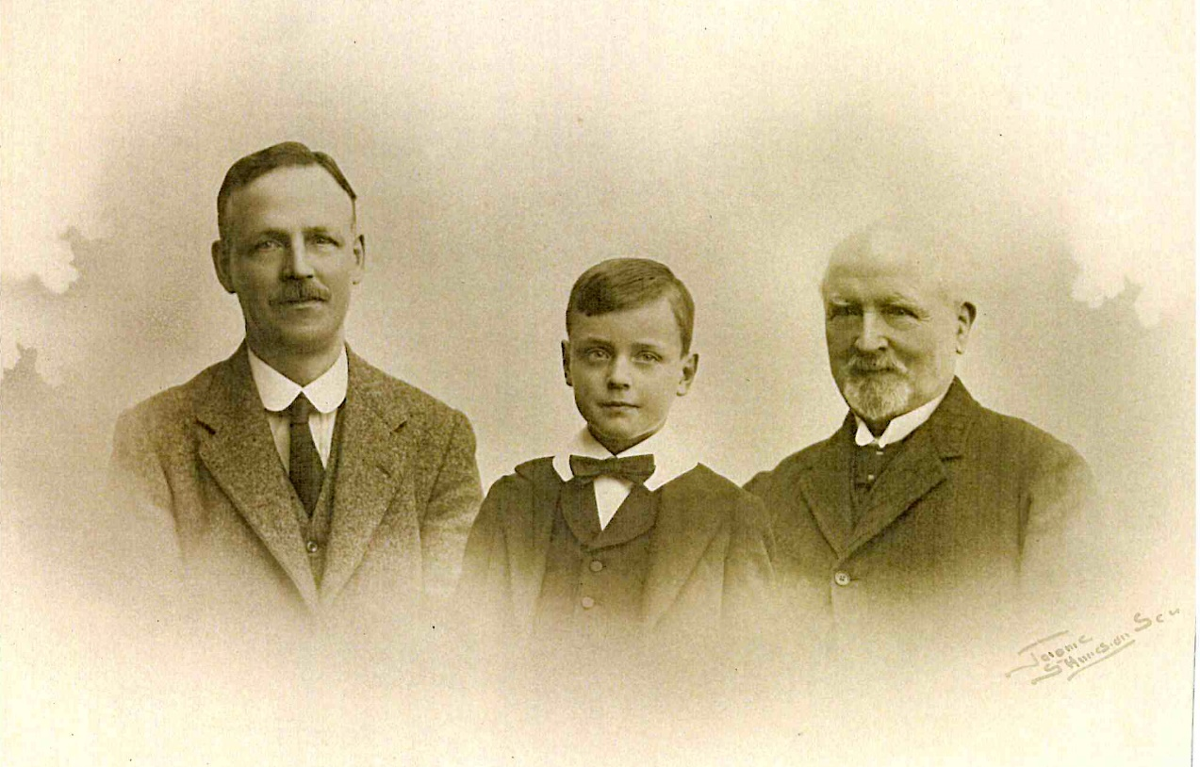
From left to right James Fletcher Junior, James (Jim) Fletcher, James Fletcher Senior, Brook Street Mill

